MAT 3749 1.3 Part I Handout
Just For Fun……ction?
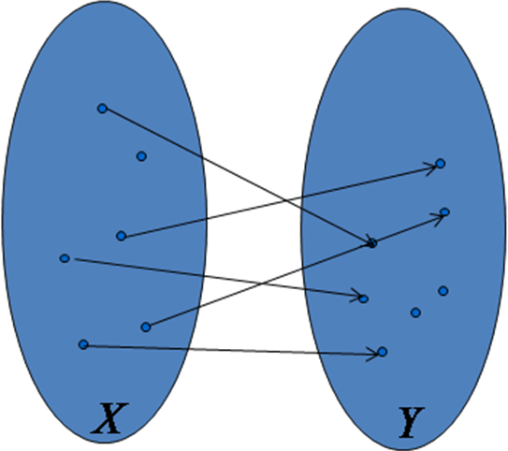

One-to-One Functions
is 1-1 (injective) if for each , there is at most one such that . | 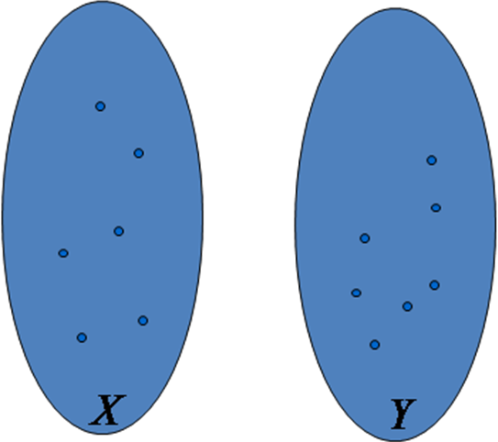

Equivalent Criteria
For ,

Example 1
Determine if the given function is injective.

Onto Functions
is onto (surjective) if the range of is .

Equivalent Criteria
Example 2
Determine if the given function is surjective.

Count Your Blessings…
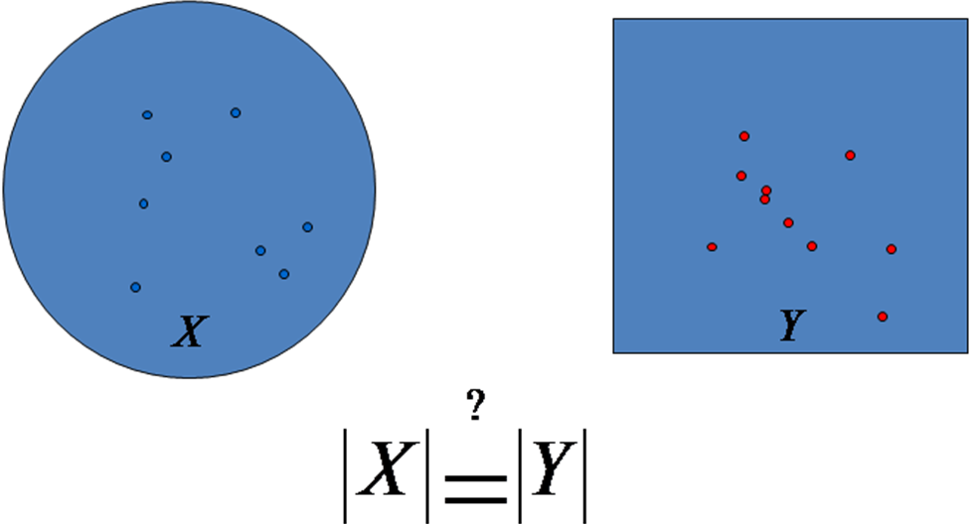

Bijections
is bijective if is both 1-1 and onto.

Inverse Functions
If is bijective, then its inverse function exists and is also bijective.
Equivalent Sets
Two sets and are equivalent if there is a 1-1 function from onto .

Example 3
The set of odd and even integers are equivalent.

Analysis

Proof

Countable Sets
A set is countable if it is either finite or is equivalent to.

Remark
If an infinite set is countable, then we can list its element as a sequence
.

Theorem
The interval is not countable.

Analysis

Proof
Suppose is countable. Since is not a finite set, the elements of can be listed as a sequence . For each of the real number , we can represent it by its infinite decimal expansion. Thus, the sequence is
,
where each .

Construct a real number such that ,
.
Then,
1. .
2. , which is a contradiction to .

Thus, is not countable.

Corollary
The reals are equivalent to , and are hence uncountable.

HW

Theorem
The set of rationals is countable.

Proof Outline

1. List all the positive rational numbers as follows:

2. Form a sequence by following the arrows and omitting any number that have already appeared.

3. The sequence list all the rational numbers.

Classwork (Family of Sets)
In this classwork, we are going to review the concept and notations of Family of Sets. Below, and represent open and closed intervals respectively.

Recall
Let and be two sets.
and .

1. We know . Let be sets for . What do you think the notation represents?

2. Let for . Find .

3. Let for . Find .

Variations
can be written as for

4. Let for and . Find .

5. Let for and . Find .

Here are the formal definitions for the union and intersection of families of sets.

Definition
Let be a set and be a family of sets. Then,
and .

6. Let for .
(a) Make an educational guess on the explicit interval form of . No need to actually prove your answer. You will do it in your HW.

(b) Make an educational guess on the explicit interval form of . No need to actually prove your answer. You will do it in your HW.

